Loggingexample.java
package com.example;
import org.slf4j.Logger;
import org.slf4j.LoggerFactory;
public class loggingexample {
private static final Logger logger =
LoggerFactory.getLogger(loggingexample.class);
public static void main(String[] args) {
logger.error("This is an error message");
logger.warn("This is a warning message");
}
}
In pom.xml -removed unnecessary plugins and added Execplugin
<build>
<plugins>
<plugin>
<groupId>org.codehaus.mojo</groupId>
<artifactId>exec-maven-plugin</artifactId>
<version>3.1.0</version>
</plugin>
<plugin>
<groupId>org.apache.maven.plugins</groupId>
<artifactId>maven-compiler-plugin</artifactId>
<version>3.13.0</version>
<configuration>
<source>17</source>
<target>17</target>
</configuration>
</plugin>
</plugins>
</build>

Output:
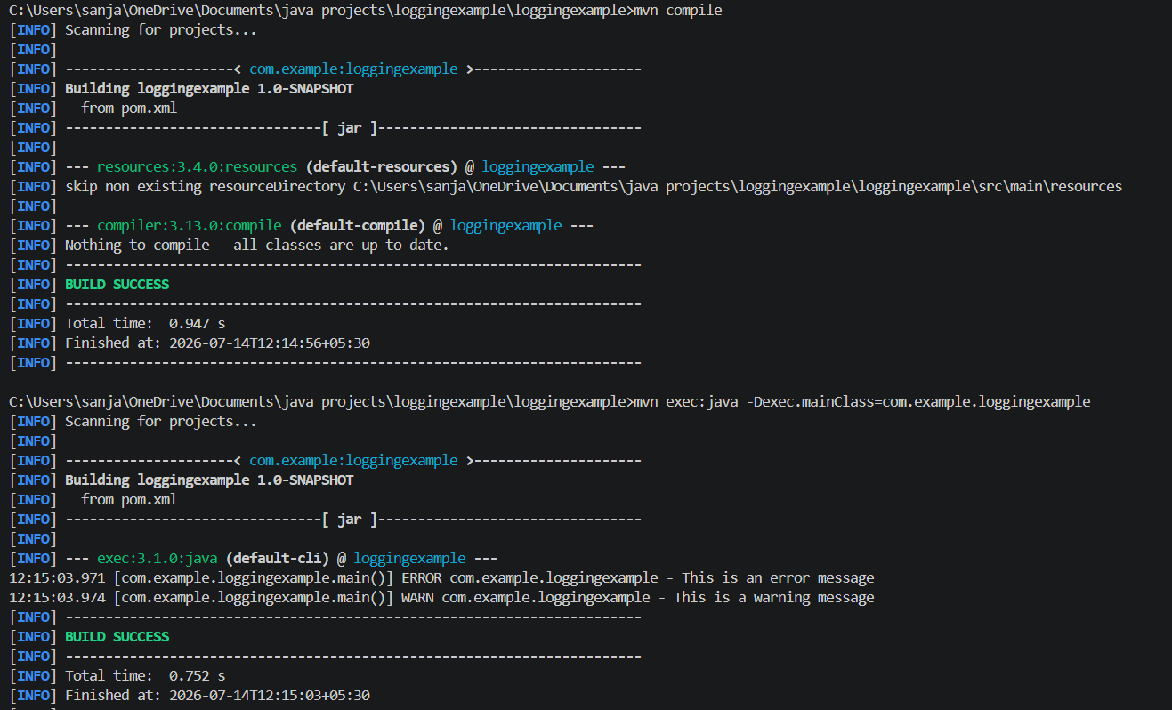
Images:
